Description:
"There is Science, behind everything that we do".
You should have known about the Discovery channel program "Science of Stupid". Our event "Science Behind It" is similar to that. Here the participants should bring a video about something that was done without the knowledge of Science and they should explain why the end result in the video failed and they should also explain the Science in it.

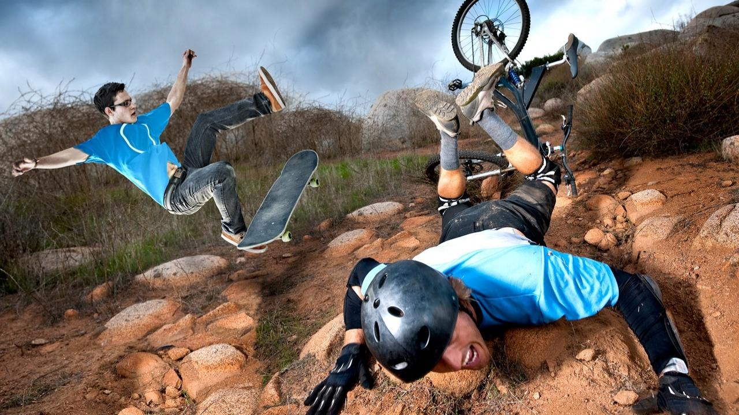

Note:
Even a video from "Science of Stupid" can be taken by the Participants and they can explain the video.

