Description:
In Drag Race an Inclined wooden slab and a Cylindrical object will be given to the Participants. Using the given Inclined wooden slab the Participants should make their own inclination and they should release the Cylindrical object from the top of the inclined slab.

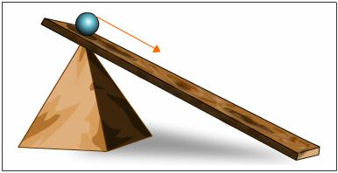

How far the object rolled in the floor from the inclined slab will be measured (The object released should reach Maximum distance).
Items that will Provided:
- Inclined wooden slab.
- Cylindrical Object.

